【COSCUP 2020 寄件須知】

由[COSCUP 物流組](http://coscup.org/)製作，以[創用CC 姓名標示 4.0 國際 授權條款](http://creativecommons.org/licenses/by/4.0/)釋出。 Produce by COSCUP

# 一、寄件資訊 Package Information

請依照以下的寄件資訊出貨：

Please write in the following format

|  |
| --- |
| 114-66 台北市內湖區民權東路 6 段 2 號 1 樓  全統物流 王宥糖小姐 收  ( 02 ) 2792 - 9955 # 311  備註：開源人年會 COSCUP |

|  |
| --- |
| ZIP Code : 114 - 66  1FL, NO.2, SEC.6, MINQUAN EAST RD., TAIPEI, TAIWAN.(R.O.C.)  Receiver : Ms. Wang Chyuan-Toong Logistics Co.Ltd.  ( 02 ) 2792 - 9955 # 311  Remark : COSCUP |

# 二、收件日期 Date of service

開放收件時間為：**06 / 30 ( 二 ) ～ 07 / 29 ( 三 )** ， 請務必於時限內送達

We receive the packages from June 30 ( Tue.) to July 29 ( Wed.) , please make sure it will arrive in time

# 三、寄件流程 Restriction

1. 拒收任何 **3C產品、電子儀器等電子設備**以及**無法堆疊或易碎的物資**，如堅持寄出而在寄送或存倉過程中造成損毀或遺失，全統物流及 COSCUP 大會概不負責。

3C products, electrical instrument or breakable stuff are not acceptable. If you insist on sending these items, COSCUP will not take any responsibility for the damage or lost items.

1. 倉庫空間有限，各單位限制 **5個 65cm x 45cm x 40cm 紙箱**空間，且為了顧及志工與工作者之人身健康安全，單一物件重量限制為**10公斤**以下，如需運送大材積物資或超重物資請及早來信通知。 例如：大型展示架、桌椅等占體積物資

Due to limited warehouse space and well beings of workers and volunteers, every units are allowed to mail 5 packages maximum ( package size : 65*45*40cm) and each cannot exceed 10 kg. If there’s any need for mailing larger or overweighted goods, please inform us in advance.

1. 出貨前，請將 [**物流單**](https://docs.google.com/document/d/1-cO8vrge1QZqWULv2bZ6TkDoI4Sd5a5rfJitGnBQOy8/edit?usp=sharing) 印下後填寫，貼在包裹上明顯的位置，以利辨認

Please print out the [**Accessory Form**](https://docs.google.com/document/d/1-cO8vrge1QZqWULv2bZ6TkDoI4Sd5a5rfJitGnBQOy8/edit?usp=sharing) , filled it out and paste on the packages before shipping.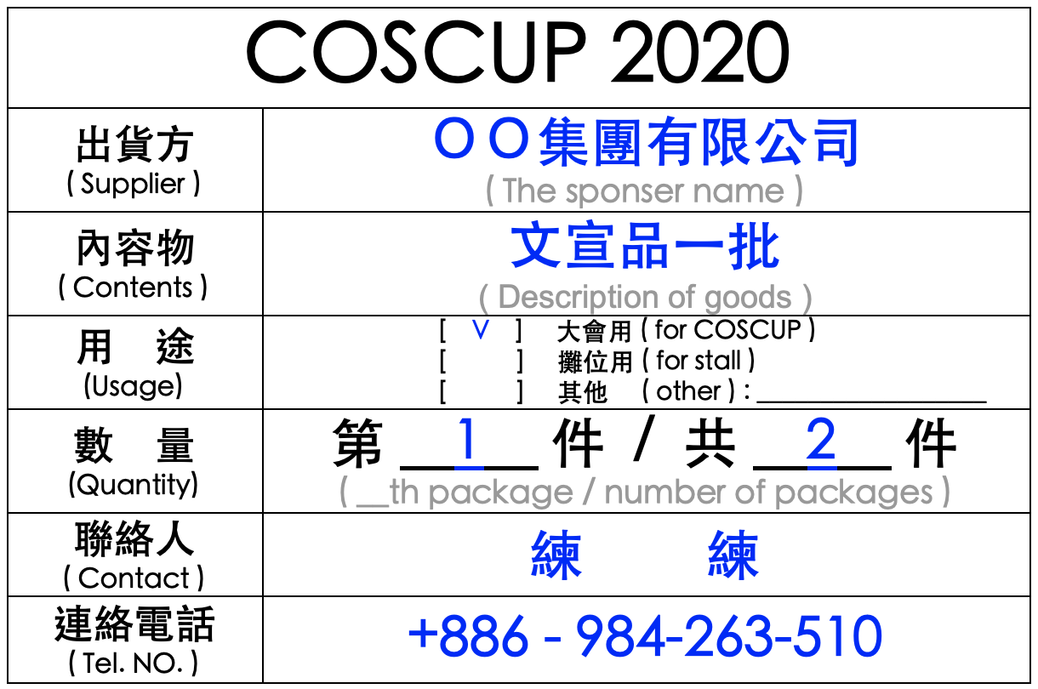

▲上圖為物流單範例

1. 請務必填寫 [**倉儲物流申請表**](https://forms.gle/HvQkiHLc6pnu2NHx5)，以供追蹤貨物流向

Please fill out the [**Application form**](https://forms.gle/HvQkiHLc6pnu2NHx5) so that we can trace your goods.

# 四、活動當天倉儲須知 Notices for the day of the event

1. 場佈日以及活動日請於 研揚大樓 5 樓 TR516 倉儲區 取貨

During the time, please get your packages at 5F ( Room No. 516 )

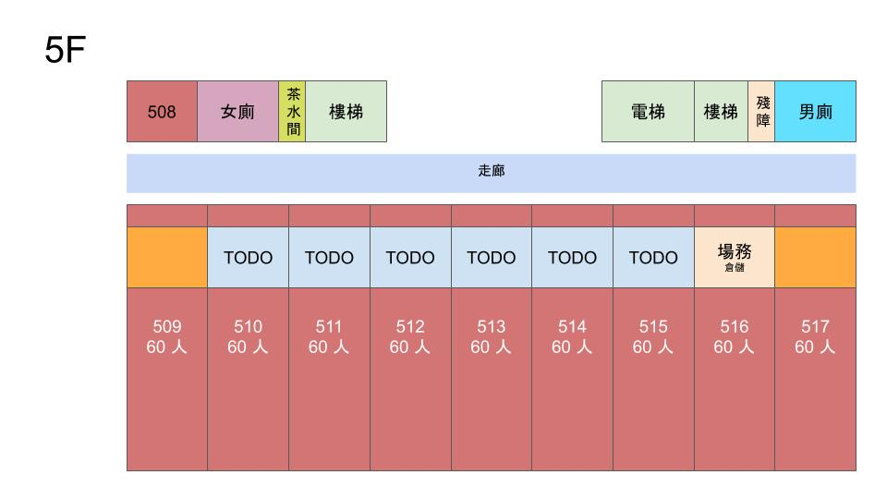

1. Day0 以及 Day1 研揚大樓 1F ~ 5F 會上鎖，故不提供倉儲服務

We will lock 1-5F in Day0 and Day1, no warehouse service at that time.

1. 大會現場不提供推車，也不提供回程物流服務，請務必確認您的貨物處理妥當。

We don’t provide trolleies nor backhaul delivery at the venue. Please be sure to deal with your goods properly.

# 

# 五、附件 Reference

## 附件一：COSCUP 物流單 Accessory Form

pdf 連結：[COSCUP 2020 物流單.pdf](https://drive.google.com/file/d/1ibPso-dE08q_u5gei4bPAo10SbAMQpkr/view?usp=sharing)

## 附件二：COSCUP 倉儲物流申請書 application form

表單連結：<https://forms.gle/HvQkiHLc6pnu2NHx5>